**MS10ZS(ZW30S) S2 In-wall Smart ON/OFF Switch**

**ID: 0312 EE00 EE01 Z-Wave SDK:**

**Software Version: 1.0 Hardware Version: 1.0**

**Parameter:**

1: Locally Button function(quickly press UP 8x) (succeed GREEN LED flash 3 times)

Parameter=1，Size=1Default = 0

Value=0 Up Button:On .Down Button: Off

Value=1 Up Button:Off .Down Button: On

Value=2 Up Button: On/Off .Down Button: On/Off

Parameter 1: Choose if you want the upper paddle to turn the light on or turn the light off when tapped, or if you'd like any paddle to change the state of the light.

Values: 0 – Upper paddle turns the light on, lower paddle turns the light off (default);

Values:1 – Upper paddle turns the light off, lower paddle turns the light on;

Values:**2 – any paddle changes the state of the light**

2: LED Indicator (quickly press DOWN 10x) (succeed GREEN LED flash 3 times)

Parameter=2，Size=1， Default =0

Value=0 On when Off and Off when On

Value=1 On when On and Off when Off

Value=2 Always Off

Value=3 Always On .

4: Auto Turn-Off Timer (minutes) – default setting. (succeed GREEN LED flash 3 times)

Parameter=4，Size=4，Values: 0 – 65535 (minutes);  .

6:Auto Turn-On Timer (minutes) – default setting. (succeed GREEN LED flash 3 times)

Parameter=6，Size=4，Values: 0 – 65535 (minutes);

8: Restores state after power failure(quickly press DOWN 8x) (succeed GREEN LED flash 3 times)

Parameter=**8**，Size=1Default =2

Value=0 output off

Value=1 output on

Value=2 out put the state after power

**Association Group:**

**Group 1 supports 1 node ID,Group 2 Supports maximum of 5 node ID’s**

**Association group_1:Z-Wave Plus Lifeline**

Association Group 2：Send Basic Set ON / Off

**Scene:**

**Scene 1:** Tap- Down -2

**Scene 2:** Tap-Up-2

**Locally Button Press function:**

1: press 1x: turn output ON or OFF

2: quickly press 2x: send scne1/scene2

3: quickly press 3x: inclusion or exclusion

4: quickly press DOWN 10x: change Parameter 2

5: quickly press UP 8x: change Parameter 1

6: quickly press DOWN 8x: change Parameter 8

7: Factory reset：click Z-Wave button 2 times quickly, and hold for at least 10 seconds.

**----LED indicate:**

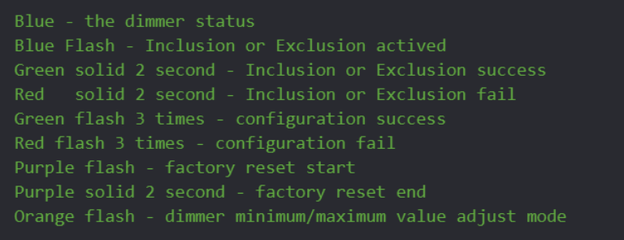

COMMAND CLASS:

